NFD DASHBOARD TOOL USAGE GUIDE

Note - This document is intended as a guide for the end-user, and not a technical guide to the setup or the algorithmic background for the tool. In case you have issues, please contact the team at Vanderbilt for help.

Development Team:

Faculty Members –

1. Abhishek Dubey
2. Yevgeniy Vorobeychik
3. Gautam Biswas

Students –

1. Zilin Wang
2. Ayan Mukhopadhyay
3. Geoffrey Pettet
4. Fangzhou Sun

Table of Contents

Modes 4

Background Jobs 4

Modes - description 5

Historical Mode 5

Prediction Mode 7

Explore Mode 8

Dispatch Mode 10

Background Jobs - description 12

Data Ingestion 12

Prediction Model Upgrade 12

Overall Monitoring 13

The NFD Dashboard tool is a means to visualize historical data, summarize statistics from data, predict future incidents, explore the impact of adding fire stations on response times and get real-time guidance on dispatch decisions. This document is a one-stop guide for the entire tool, and is meant to be used by the end user.

# Modes

The tool has four basic modes, with the following capabilities –

* Historical – The mode enables user to visualize historical data as heat map/ incident scatter plots on a geographical map of Nashville.
* Prediction – Enables the user to predict incidents for arbitrary future dates according the incident type.
* Explore – Lets the user add a new fire station,
* Recommend – Lets the user calculate a new station’s effect on the response time.
* Dispatch – Helps the user in plotting pending incidents that need to be serviced, and provides a recommended dispatch decision.

# Background Jobs

The tool has three primary background jobs – data ingestion to the mongoDB used by the dashboard, upgrade of the prediction algorithm with streaming data and overall monitoring of the tool. We discuss the modes as well as the jobs individually in this document.

# Modes - description

## Historical Mode

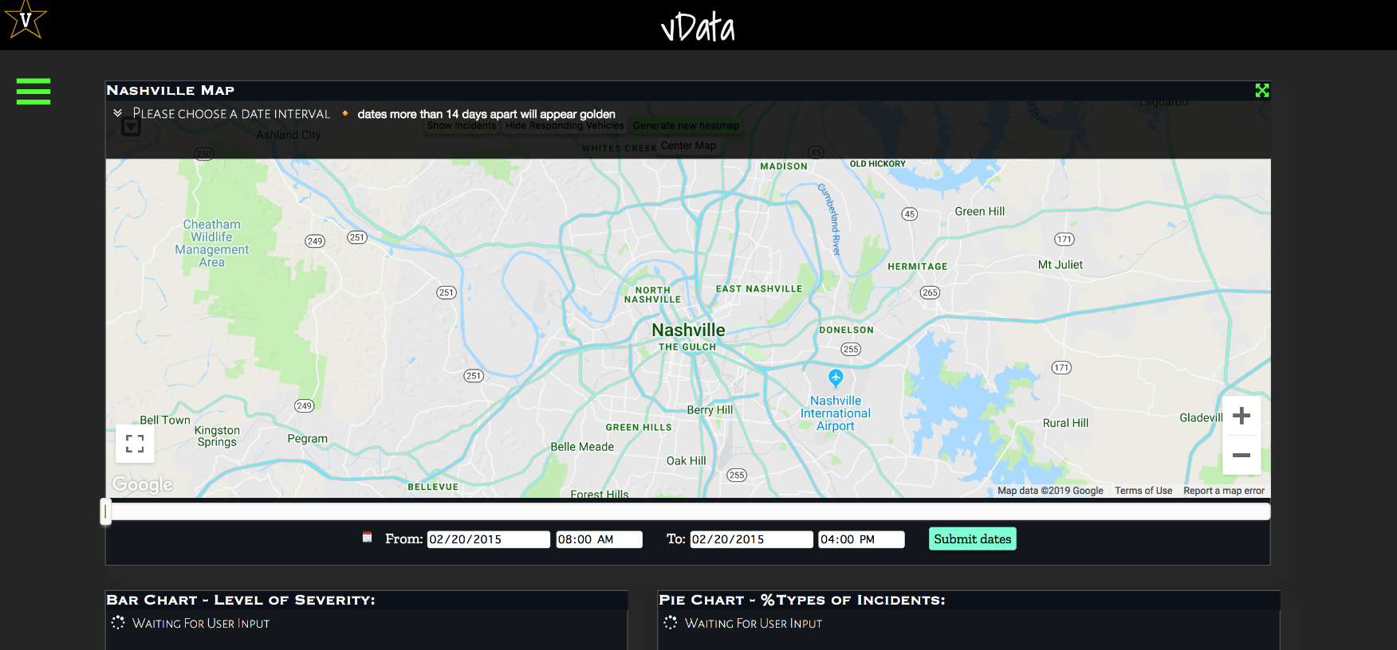

Figure 1: Home Screen

The tool starts with the home screen shown in Fig. 1, waiting for the user input. To work with the historical mode, one should –

* Select a date range using the date slider/calendar input box (the tool populates the earliest and latest dates available for selection by itself, based on the available data).
* Date ranges less than or equal to 14 days show individual incidents (Fig. 3). To avoid cluttering the map, date ranges greater than this are shown as heat maps (Fig. 2).
* Upon selecting the date range, the user should click the submit button, which loads the map and the statistics (Fig. 4), as shown in the figures below.

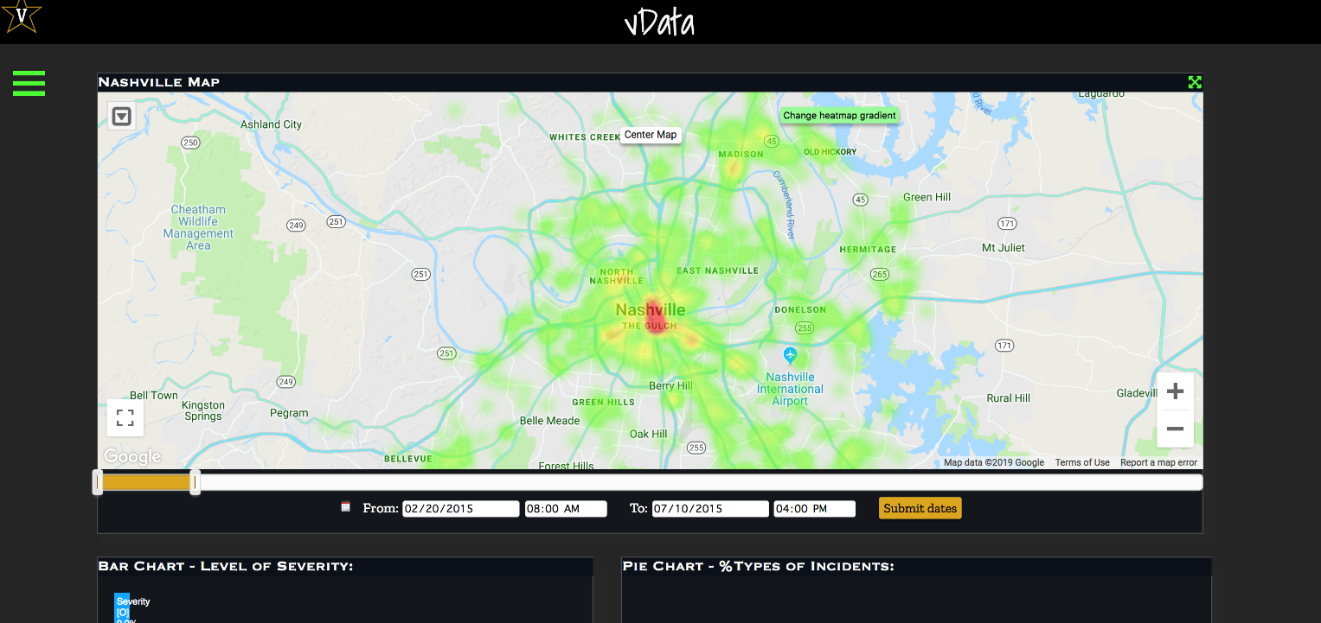

Figure 2: Heat Map (Date Range > 14 days)

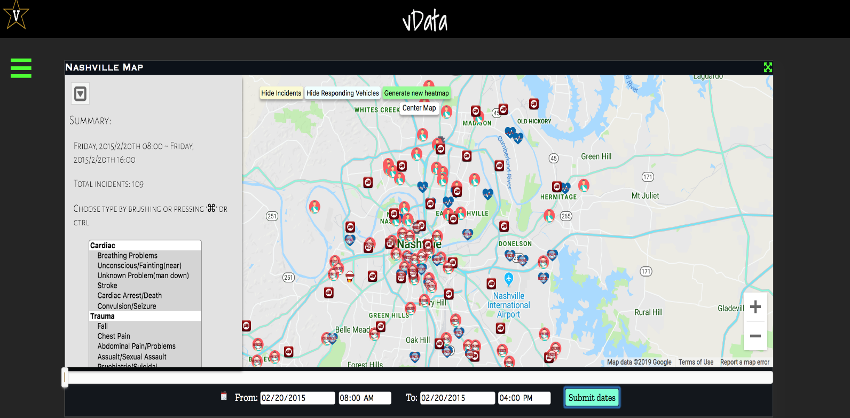

Figure : Incident Map (Date Range <= 14 days)

Given a date range less than 14 days, the user can also select a subset of incident types from the side pane (e.g. cardiac, trauma etc.) and choose to visualize the chosen incident type only, providing more granularity in visualization.

The summary statistics provide a breakdown of incidents according to severity in the form of a bar chart, as well as a breakdown of incidents by category/cause (chest pain, fall, sexual assault, stroke etc.) in the form of a pie chart.

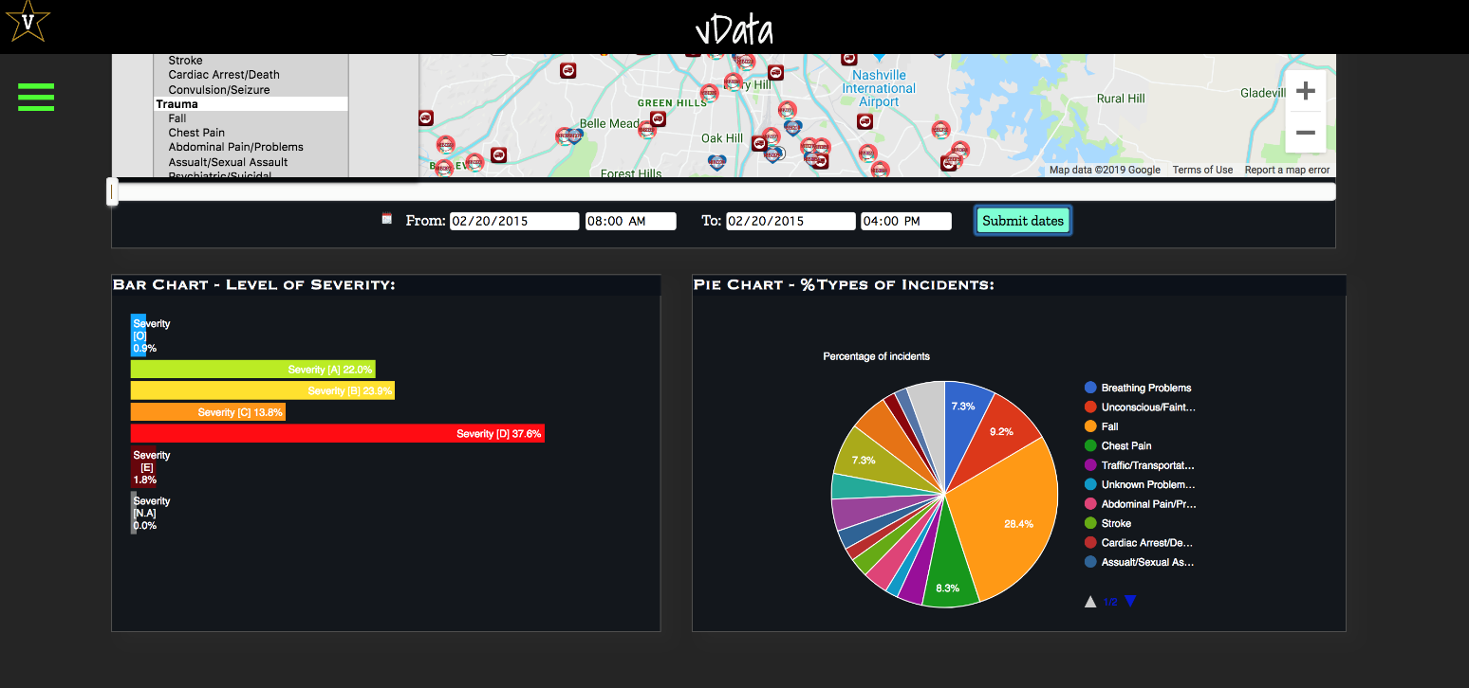

Figure : Summary Statistics of Historical Data

## Prediction Mode

As highlighted before, the tool has four modes – historical, prediction, exploratory and dispatch. In order to change the mode, at any screen, the user can access the menu bar (using the three horizontal green bars on the left of the main screen) as shown in Fig. 5. This lets the user navigate from one mode to the other.

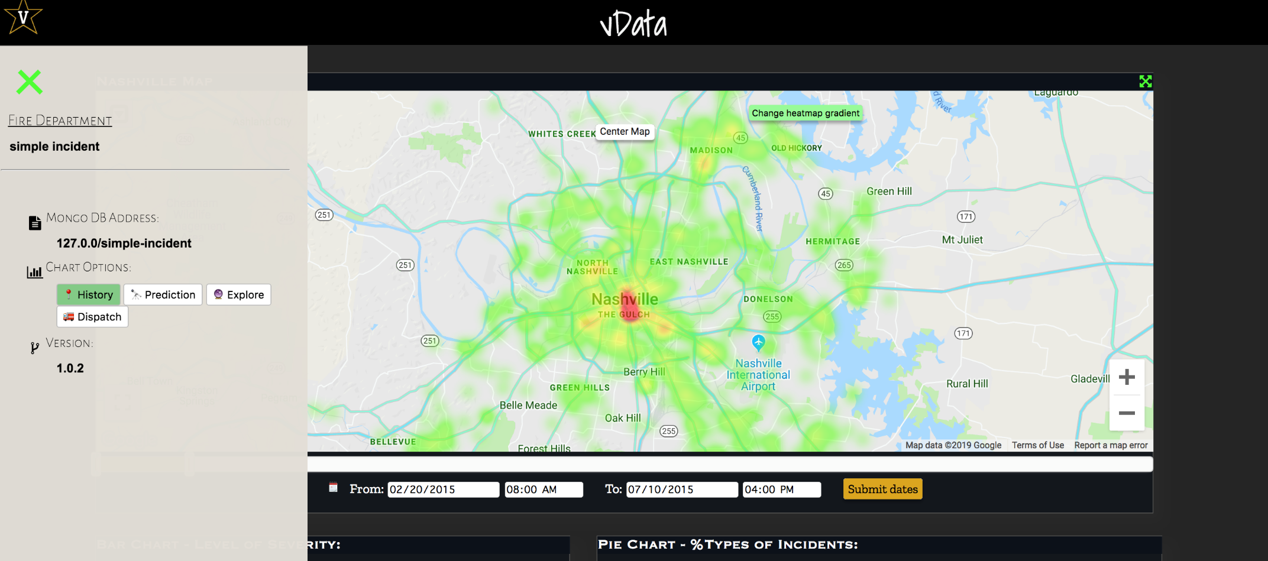Figure : Menu Modes

Once in the prediction mode, the user can:

* Select a particular category of incidents (Fig. 6).
* Move the date slider to a future date, at which the user needs a prediction for incident density.
* Click on the submit button to load the prediction map. The following figure shows an example prediction for the “cardiac” incident category (Fig. 7).

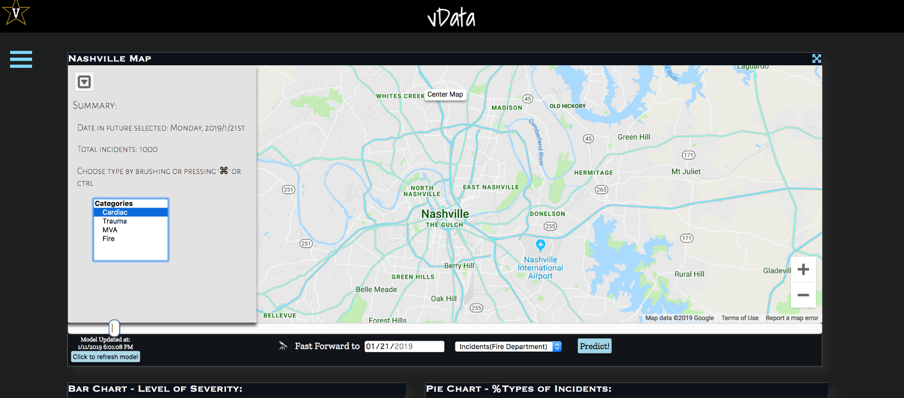

Figure : Choose Prediction Category

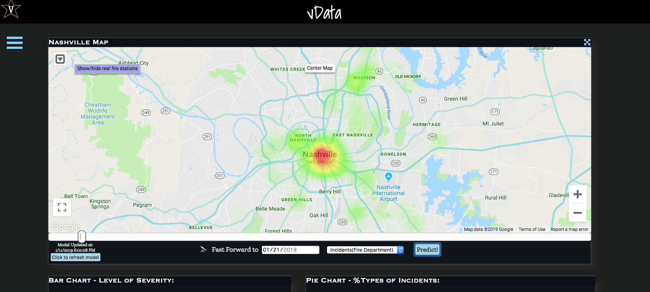

Figure : Prediction Heat Map

## Explore Mode

The explore mode lets the user add a fire station, with the mean number of responders across existing stations, and calculate its effect on the response time. In order to do so, the user needs to:

* Navigate to the explore menu from the menu bar, as shown in Fig 5.
* If the user wants, she can display the existing fire stations by pressing the “show/hide real fire stations” button on the map. This loads the existing fire station and responder information. On clicking any station, the user can see the responders assigned to the station (Fig. 8).
* Then, user can add a station by clicking the “add a fire station” button, and drag the fire station to the desired location (Fig. 9).
* Finally, on clicking the “Submit a new fire station location” button, the user can get the summary of difference in response times due to the new station (Fig. 10).

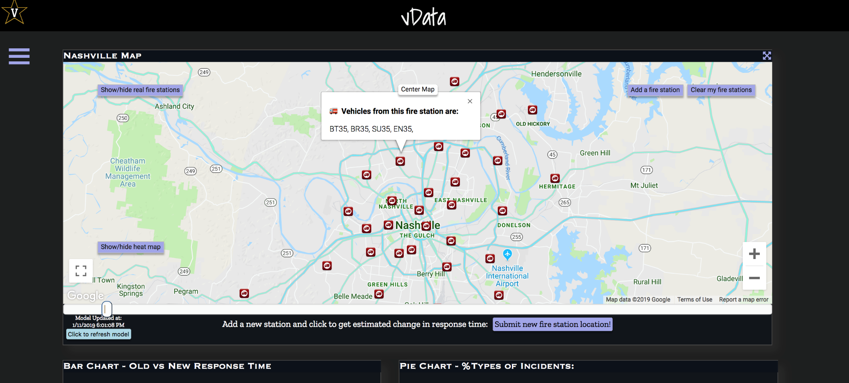

Figure : Visualizing existing Fire Stations

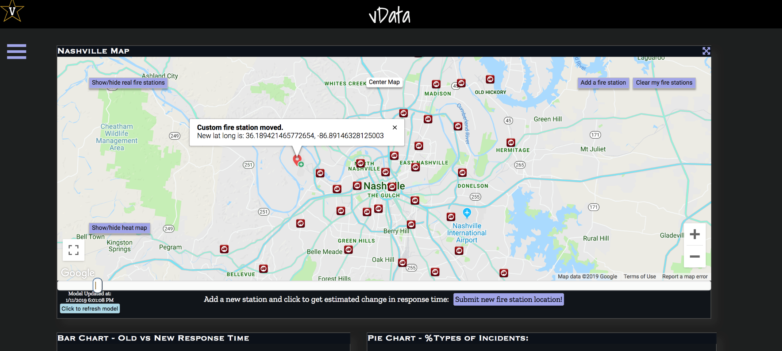

Figure 9: Adding Custom Station Location

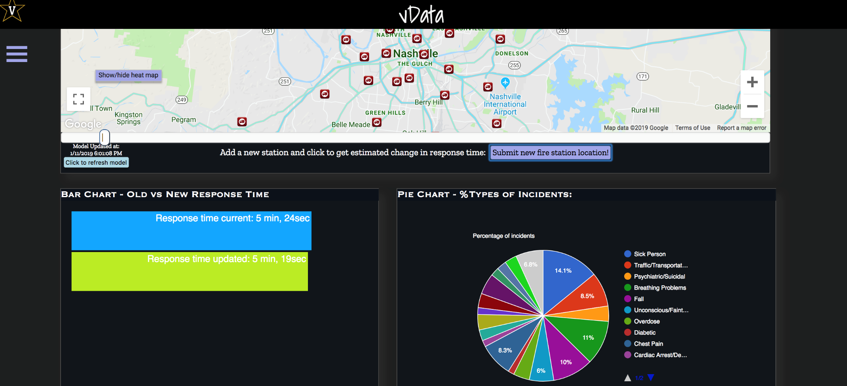

Figure : Response Time Optimization Summary

## Dispatch Mode

The dispatch mode lets the user get real-time guidance on servicing incidents, that have not been serviced as yet. In order to access this mode, the user needs to

* Navigate to the Dispatch mode using the mode menu, as shown in Fig. 5.
* The user can plot the pending incidents using the “Plot Pending Incidents” button (Fig. 11).
* The user can get dispatch guidance by clicking on the “Get Dispatch Decisions” button (Fig. 12).

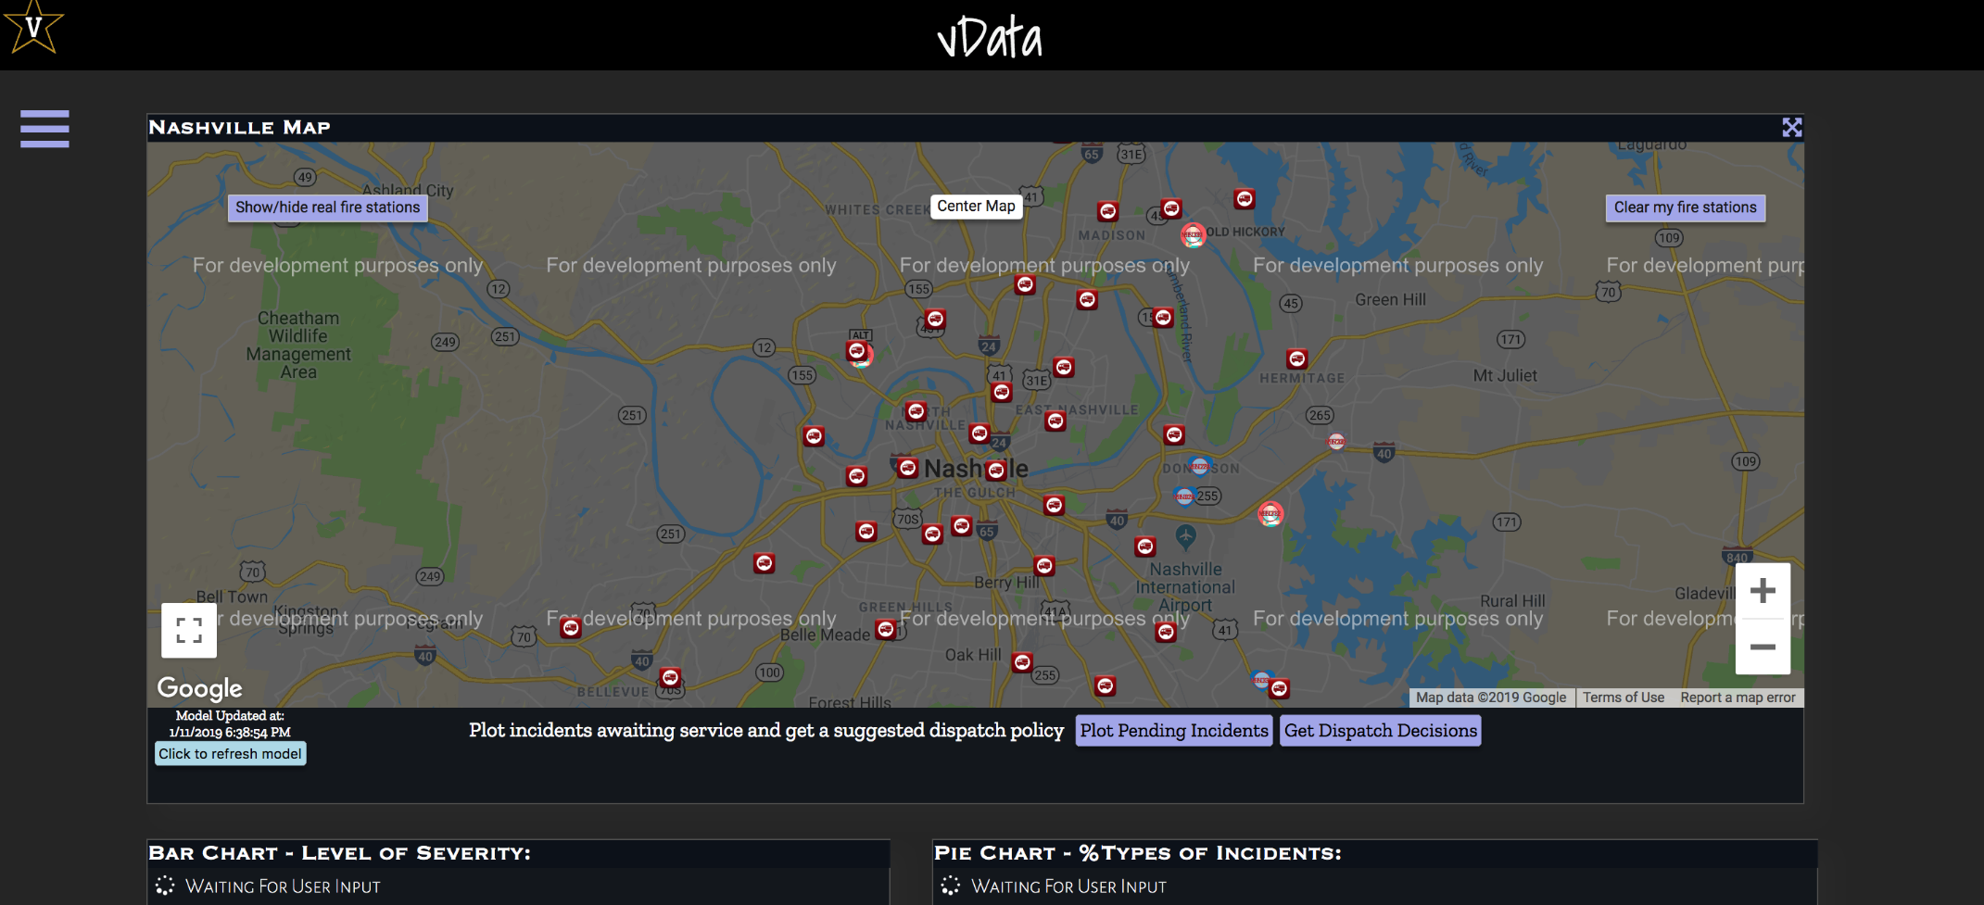Figure : Plot Pending Incidents

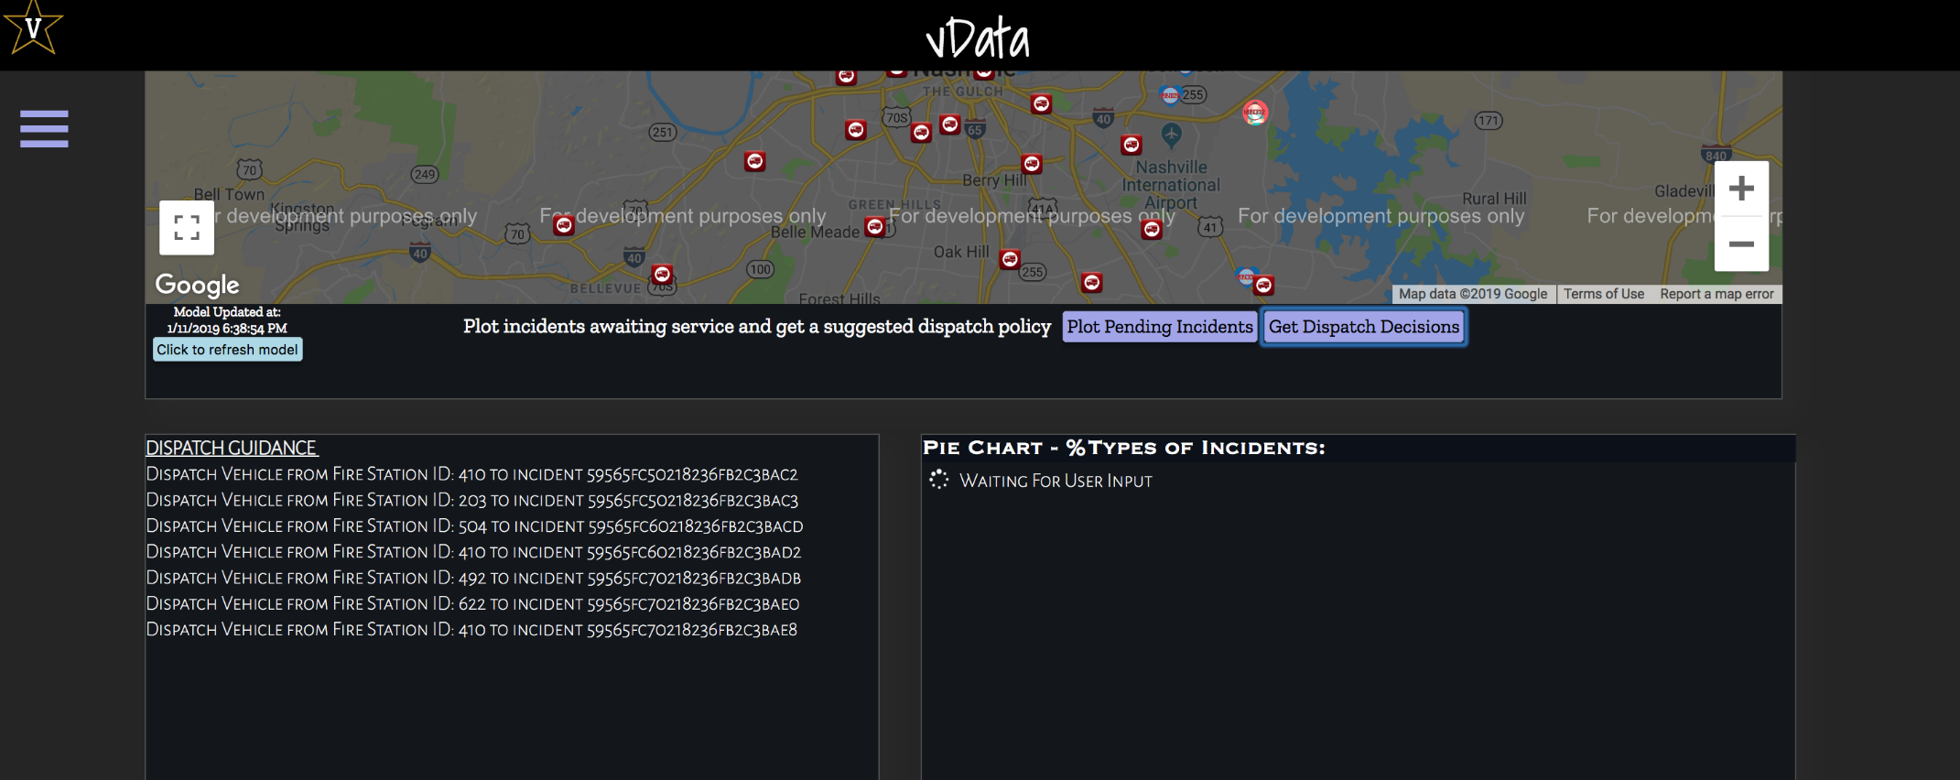

Figure : Get Dispatch Decisions

# Background Jobs - description

The tool performs three basic background jobs –

Data ingestion.

Prediction Model upgrade.

Overall Monitoring.

We describe the functionalities of these jobs now. We strongly recommend that these are changed only by the administrators who are in-charge of the dashboard.

## Data Ingestion

New incident data is transferred from the ImageTrend database to the server periodically, currently at a rate of every 3 minutes. This information must be processed and ingested into the dashboard’s database. We developed a service that does this process automatically called serv_periodic_update.service.

There are a few parameters for the service that are set in the ingest_config.cfg file (located in analytics-dashboard/update-services/). We use Darksky for getting the current weather, and it’s api key is configurable. Also, if the rate at which imagetrend sends updates changes from 3 minutes, the wait_time parameter (stored in seconds) can be changed to reflect this in the ingestion rate. The min_wait_time is the minimum number of seconds between updates, to ensure the server is not overloaded.

## Prediction Model Upgrade

The prediction model for generating heat maps at future dates is often times slow to compute on the fly. Hence the tool updates this model at regular intervals and stores the model, and directly accesses it when need be. The script analytics-dashboard/streamUpdate.py does this by calling the required back-end methods of the dashboard. The only configurable parameter for this process is the update frequency (measures frequency as the number of times update is done in 24 hours), and is located in the config file “streamUpdate.conf” located at analytics-dashboard/update-services. The default value is set to 1, which means that the model is updated once every 24 hours.

## Overall Monitoring

If the ingestion service stops or fails for some reason, we have set up a script to send an email notification to a configured email address. This address, and the sending email address can be updated in the same ingest_config.cfg file.

Note - If any of the parameters are updated, the systemd service must be restarted.